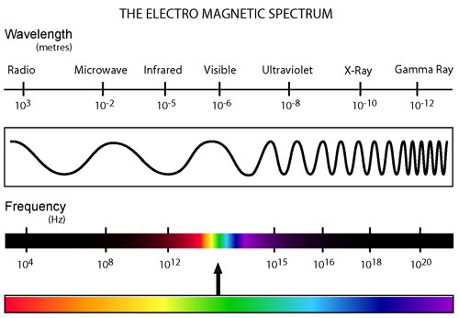
DDN Day #131
3/27/12

1. Which has a longer wavelength:
radio waves or ultraviolet waves?

2. Which has a higher frequency:
Infrared waves or x-rays?

3. Which has more energy: red waves or blue waves?

