How to Make and Name Carbon Compounds:
Prefix | Meth | Eth | Prop | But | Pent | Hex | Hept | Oct | Non | Dec
# of carbons | 1 | 2 | 3 | 4 | 5 | 6 | 7 | 8 | 9 | 10

Classification | Bond Types | Prefix + Name Ending | Formula | Example | Zig zag (chain model)
Alkane | All single | _____ane | C_{n}H_{2n+2} | 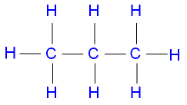  Propane C₃H₈ | Propane
Alkene | At least one double | _____ene | C_{n}H_{2n} | 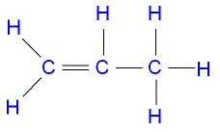  Propene C₃H₆ | Propene
Alkyne | Al least one triple | _____yne | C_{n}H_{2n-2} | 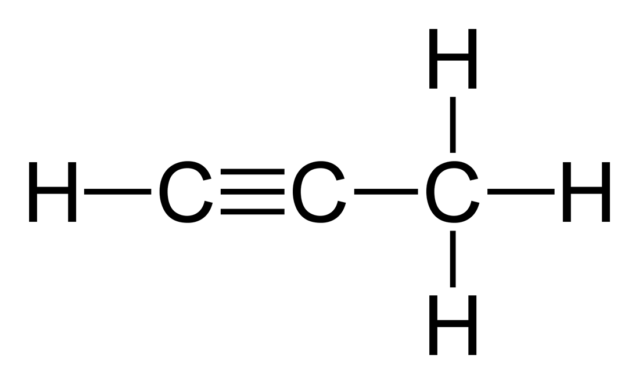  Propyne C₃H₄ | Propyne

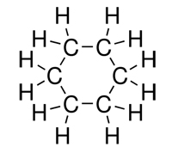  Cyclo Means “Circular” C_{n}H_{2n}  Example: Cyclohexane | -“ol” ending means alcohol C_{n}H_{2n+2}O  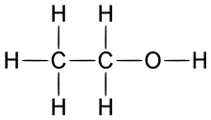  Example: Ethano
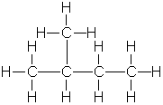
What about branching?
Example: 2-methyl butane Structural model:

Main chain of 4 carbons, single-bonded

Methyl (1 carbon) branch
Located on the second carbon

Write the molecular formula, structural formula and diagram (zig zag) each:

Pentane | 1-pentene | 1-pentyne
Cyclopentane | 2,2-dimethyl pentane | 1-pentanol

1) Draw the chain model. Then 2) write the molecular formula.
ethane  1)  2) | Hexane  1)  2)
Cyclo Heptane  1)  2) | 1-Hexene  1)  2)
2-Methyl-3-Ethyl Hexane  1)  2) | 1-Hexanol  1)  2)
1-hexyne  1)  2) | 1-Cyclo-hexene  1)  2)

