Peeps in Spaaaaaaaaaaaaaace Project!

Due Date: ____________________

Assignment:
1. Research a famous scientist/ inventor or scientific situation (selected in class) and write a short paragraph about them and their contribution to science

2. Create a shoebox diorama depicting your scientist/ inventor or situation in action.

For ideas using Peeps see: http://www.washingtonpost.com/lifestyle/magazine/peeps

* Shoebox scene should include: historically accurate clothing and buildings.
Spray paint/cover the inside of the shoebox completely so that the original box cannot be seen.
* Attach title, name of the scientist/ inventor and caption to the front, and also include lab partner names.
* Clever titles are preferable.

3. List of potential diorama topics (other ideas need teacher approval). Submit topic or name before researching or creating diorama.

Isaac Newton
Georg Simon Ohm
Benjamin Franklin
Galileo Galilei
Nicholas Copernicus
Johannes Kepler
Edwin Hubble
Neil DeGrasse Tyson
Michael Faraday
Joseph Fraunhofer
Tycho Brahe
Marie Curie
Bill Nye
Neils Bohr
Stephen Hawking
Thomas Edison
Nicola Tesla
Albert Einstein
Edmund Halley
1969 Lunar Landing
NASA control room
Yuri Gagarin
“The Martian”
“Contact”
“The Right Stuff”
“Apollo 13”
“Gravity”
“Interstellar”
“2001 Space Odyssey”

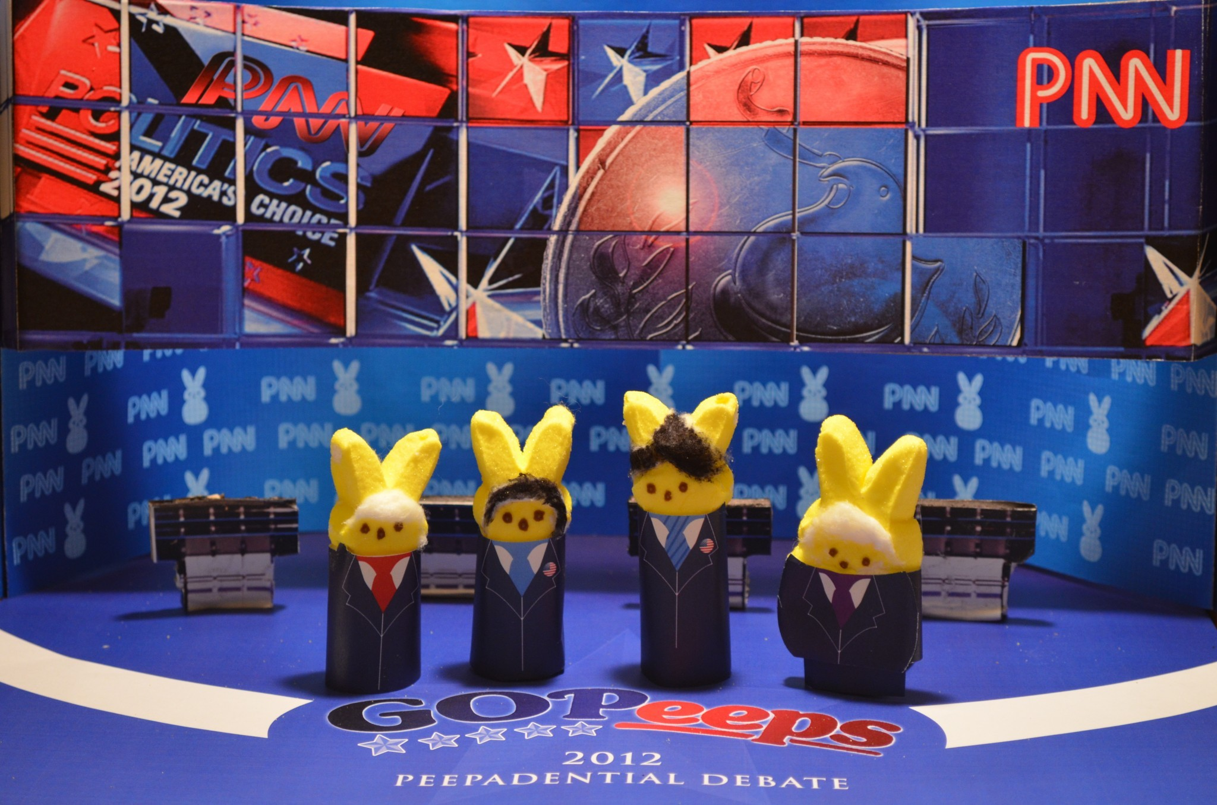
Diorama Rubric (25 points total)
10 points Quality of Construction
5 points Accuracy
8 points Caption
2 points Use of Peeps

