The H-R Diagram- Stellar Luminosity and Temperature
Introduction: Astronomers use two basic properties of stars to classify them. These two properties are luminosity, or brightness, and surface temperature. Astronomers will often use a star’s color to measure it’s temperature. Stars with low temperature produce a reddish light, while stars with high temperature shine with a brilliant blue-white light. Surface temperatures of stars range from 2,000 Kelvin to 50,000 Kelvin.
When these surface temperatures are plotted on a graph against luminosity, the stars fall into groups.

Problem: To create a Hertzsprung-Russell diagram.

Procedure:
1. Plot the stars listed below on the graph paper provided.
2. Draw a circle around each grouping of stars on the graph.
3. Label the following on your graph: Main Sequence, Red Giants, White Dwarfs,
Supergiants.
4. Circle the dot representing the Sun.
5. Color your graph (lightly) according to the following:
2,000-3,000 K = red
3,000-4,000 K = orange
4,000-6,000 K = yellow
6,000-10000 K = white
10,000-20,000 K = blue/white
20,000-35,000 K = blue
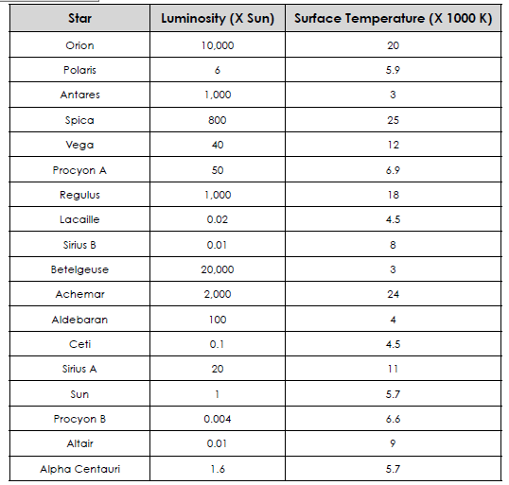
Conclusion Questions:
1. How many types of stars are shown on the H-R Diagram? __________________________

2. How does the temperature and luminosity of the Sun compare to that of the other
stars on the Main Sequence? _______________________________________________________

3. What is the relationship between luminosity and temperature for stars on the Main
Sequence? ________________________________________________________________________

4. Which is the hottest star plotted? ______________ the brightest? _____________________

Regents Questions:
1. According to the Luminosity and Temperature of Stars Earth Science reference table, the Sun is classified as a
A) blue supergiant star with a temperature of approximately 20,000K and a luminosity of 700,000
B) main sequence star with a temperature of approximately 5,500K and a luminosity of 1
C) main sequence star with a temperature of approximately 4,000K and a luminosity of 100
D) white dwarf star with a temperature of approximately 10,000K and a luminosity of 0.01

2. Which star is cooler and many times brighter than Earth's Sun?
A) Rigel
B) Betelgeuse
C) Barnard's Star
D) Sirius

3. Stars are believed to undergo evolutionary changes over millions of years. The
flowchart below shows stages of predicted changes in the Sun.

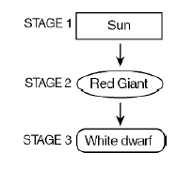
the Sun will become
A) hotter and brighter in stage 2, then cooler and
dimmer in stage 3
B) cooler and dimmer in stage 2, then hotter and
brighter in stage 3
C) cooler and brighter in stage 2, then hotter and
dimmer in stage 3
D) hotter and dimmer in stage 2, then cooler and
brighter in stage 3

