CAPT BIOLOGY BIG IDEAS
- All living things are made of cells.
- Prokaryotic cells differ from eukaryotic cells. Eukaryotic cells contain membrane-bound organelles, prokaryotes do not.
- Plant cells have cell walls and chloroplasts, animal cells do not.
- Enzymes are catalysts that speed up chemical reactions in cell processes.

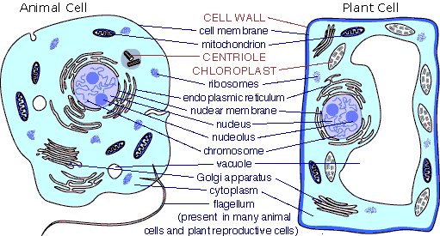

- All living things have nucleic acids (DNA and RNA). These molecules provide the instructions for the cell activities. These instructions are passed from parent to offspring.
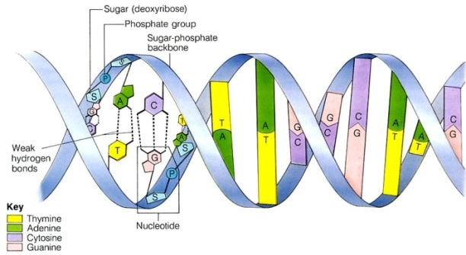
- Punnett Squares are used to predict the probability of inheriting certain traits.
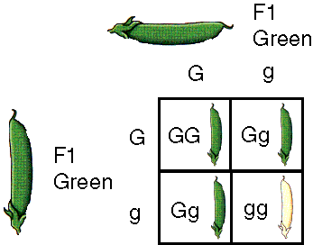
- Genetically modified organisms (GMO’s) have altered DNA that code for enhanced traits such as pest resistance.
- Most microorganisms are harmless; however, about five percent can be harmful and cause infectious diseases such as botulism and strep throat.
- Viruses are non-cellular particles that cause colds, flu and HIV/AIDS.
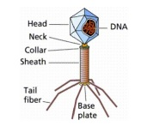
- All living things reproduce. Mitosis is asexual reproduction creating two identical daughter cells. Meiosis is sexual reproduction and produces four unique gametes (sex cells) with half the amount of genetic material as the parent cell.
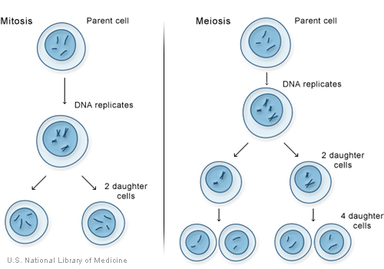
- All living things adapt to their environment. Evolution is the process by which populations of organisms change over time.
- Populations grow exponentially when there are unlimited resources. When resources become limited the population growth will slow, stabilize or drop (logistic growth).
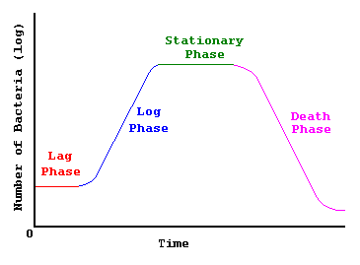

- All living things require energy. Producers capture energy from the sun. Energy flows through the trophic levels in an ecosystem.

