Study Questions for Test on Chapter 3: Our Solar System (planets, asteroids, comets, meteoroids)
- What is an AU? What does it measure?

- What is the difference between planetary rotation and revolution? (Which is a day? Year?)

- What is the solar nebula theory of planet formation? What is the approximate age of the solar system?

- How did the terrestrial (inner) planets form? What about the Jovian (outer) planets?

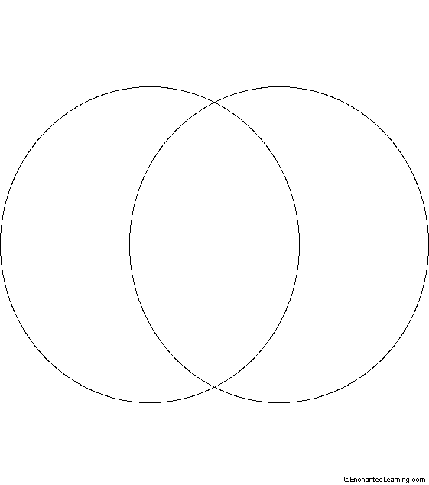
- Using the Venn Diagram below, compare/contrast the inner and outer planets in terms of: a) distance from the sun, b) relative size, c) number of moons, d) diameter/mass, e) surface features

- What is the closest star to us (besides our Sun)? How far away is it?

- Are stars inside or outside of our solar system?

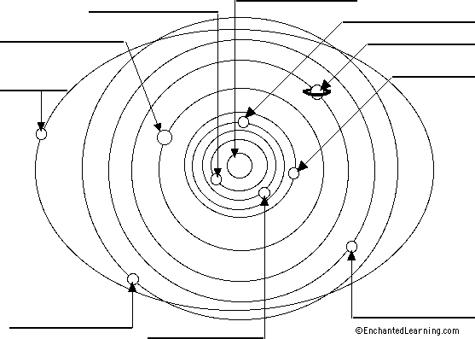
- Be able to correctly list the planets in order from the Sun. Also be able to locate the Asteroid Belt, Kuiper Belt and Oort cloud and know what objects are found in these areas.

- What are asteroids? Where in our solar system are they found? (between which 2 planets?)

- What are comets? Where in our solar system are they found? Why does a comet’s tail always point away from the sun?

- What is the difference between a meteor, meteoroid, and meteorite?
- Put the following objects in order from SMALLEST to LARGEST in size: Our Moon, asteroid, Pluto, comet, meteoroid, Saturn

- Now put the same objects (from #11) in order of DISTANCE FROM EARTH (CLOSEST FARTHEST)

- ASK YOUR CLASSMATES:
-Find out one interesting or fun fact about each of the following:
Mercury

Venus

Earth

Mars

Jupiter

Saturn

Uranus

Neptune

Pluto

