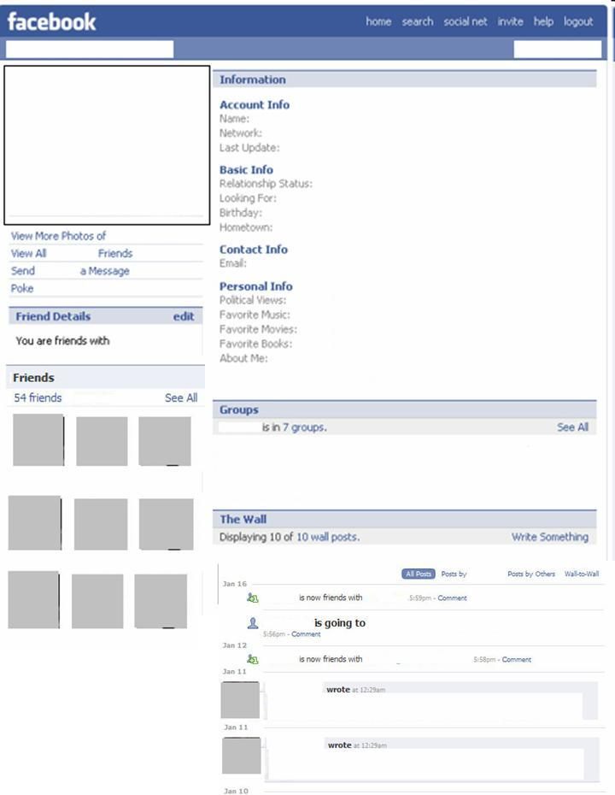

Atomic #:_____

Atomic mass:_______

Solid, liquid or gas?____________

Metal, nonmetal or metalloid? ____________

Valence electrons:_____

Oxidation #:_____

has now bonded with

has now bonded with

Element name:

Element symbol:

Row in Periodic Table:

**Family/Group members**

By _______________ in the year ________.

**Discovery Info**

Bohr Model of Element:

**6**

Group or Family location in the Periodic Table:

# of protons: ____

# of electrons:____

# of neutrons:____

for elements