Study Guide for Chemistry Part II Test
Chemical Bonds
-Elements bond with other elements because they want their electron shells (energy levels) to be full.
-Octet Rule states that most atoms need 8 electrons in their outer shells to be full and “happy.”

-Metals (left side of Periodic Table) lose their extra electrons and have positive charges. Example:
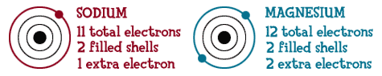

Gain or lose electrons? _________ Gain or lose electrons? _________
Charge _______________ Charge ________________

Nonmetals (located to the right of the “staircase”) usually gain electrons to fill their shells. Example:
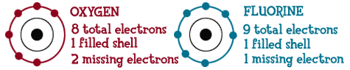

Gain or lose electrons? _________ Gain or lose electrons? _________
Charge _______________ Charge ________________

-Ionic bonds usually form when metals transfer electron(s) to nonmetals. Ions are formed! Example:
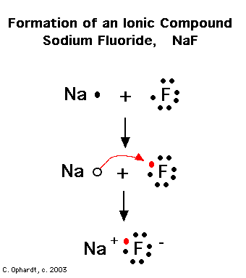
Na transfers 1 electron to F

Ionic compounds:
*are solid at room temperature
* are good conductors of electricity
*break up in water; ex. Salt (NaCl) in water

Covalent bonds usually form when nonmetals share electron(s) so that each have 8 (except for Hydrogen). See example of Cl₂:
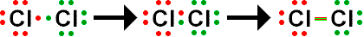

Covalent compounds:
*are liquid or gas at room temperature
* are poor conductors of electricity
*do not break up in water; ex. Carbon dioxide (CO₂) bubbles in water

Identify each compound below as ionic or covalent. Refer to the Periodic Table to determine metals/nonmetals:
a). Li₂O _______________________ d). KOH _______________________
b). C₆H₁₂O₆ ____________________ e). H2O _______________________
c). NaHCO₃ ____________________ f). CO ________________________
Draw the Lewis Dot Structure for each compound below and state whether it shows an ionic or covalent bond. ONLY SHOW THE VALENCE (OUTER) ELECTRONS FOR EACH ATOM.
Compound | Dot Structure | Ionic or Covalent?
CH₄ (methane)
LiOH
N₂

Na₂S

Balancing Equations
1. What is the Law of Conservation of Matter? How does this relate to balancing equations?
-Circle the equations that are ALREADY BALANCED from the examples below
1) Na + Cl₂ NaCl 2Na + Cl₂ 2NaCl 2Na + Cl₂ 2NaCl
_____________________________________________________________________
2) Ca + Cl₂ CaCl₂ 2Ca + Cl₂ 2CaCl₂ Ca + 2Cl₂ 4CaCl₂
_________________________________________________________________________
3) FeCl₂ + K₂S FeS + KCl FeCl₂ + K₂S FeS + 2KCl 2FeCl₂ + K₂S 2FeS + 2KCl
______________________________________________________________________________
4) 2C₂H₂ + 5O₂ CO₂ + 2H₂O 2CH₄ + 5O₂ 2CO₂ + 4H₂O 2C₄H₁₀ + 13O₂ 8CO₂ + 10H₂O
______________________________________________________________________________
5) UO₂ + HF UF₄ + H₂O UO₂ +4 HF UF₄ + 2H₂O 2UO₂ + 4HF UF₄ + 4H₂O

Acids and Bases
- What is the pH scale used to measure? What does pH stand for?

- Write in where each of the following belongs on the pH scale below: strong acids, strong bases, weak acids, weak bases, neutral

Acids
-range in pH from 0-6.9
-sour if tasted
-good electrolytes (conduct electricity)
-produce H+ ions in water

Bases
-range in pH from 7.1-14
-bitter if tasted
-good electrolytes (conduct electricity)
-produce OH- ions in water

Matching
_____1). Baking soda a. acid

_____2). Taste sour b. base

_____3). Are slippery c. both a and b

_____4). Taste bitter d. neutral substance

_____5). vinegar

_____6). Produce hydroxide (OH-) ions in water

_____7). Produce Hydrogen (H+) ions in water

_____8). pure water

_____9). Naturally occurring rain

_____10). Can be very dangerous if used incorrectly

Neutralization
When you mix an acid with a base, you form a neutral salt and water.
-The H+ (from acid) combines with the OH- (from base) to form water.
-The remaining parts make up the salt. Find their charges and write them as a neutral compound (criss cross). See example:

H₂SO₄ + KOH ___H20__________ + ___ K₂SO₄__________
H₂SO₄ + KOH

Form H₂O + K has +1 charge SO₄ has -2 charge, so:
K₂SO₄ (Criss Cross)

Write the balanced equation for these neutralization reactions: (remember to balance charges for ionic compounds!)

a) HCl + NaOH _____________________ + ______________________

b) HNO₃ + KOH _____________________ + ______________________

c) Ca(OH)₂ + H₂SO₄ _____________________ + ______________________

d) Mg(OH)₂ + H₃PO₄ _____________________ + ______________________

e) H₂C₂O₄ + Ca(OH)₂ CaC₂O₄ + _____________

Extra Practice

For more balancing equations practice, visit http://education.jlab.org/elementbalancing/index.html or scan the QR code below

For more info on acids and bases visit http://chem4kids.com/files/react_acidbase.html or scan the QR code below.

For more info on ionic and covalent bonding, visit http://chem4kids.com/files/atom_bonds.html or scan the QR code below.

