DDN Day # 104 2/9/12
The diagram shows a double paned glass window. Label where conduction, radiation, and convection are occurring. Explain why these windows are better insulators than single pane glass ones.
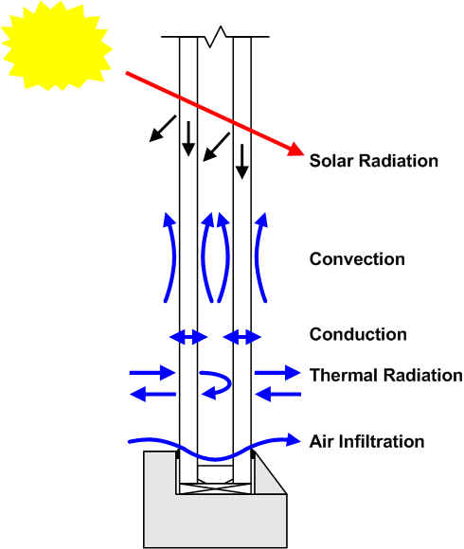
3._________________________
2. _________________________
1. _________________________

