Doppler Effect Math Problems
-Remember: λ = wavelength and is measured in nanometers (nm)
Things to consider:
-Glowing gases (like Hydrogen and Helium) emit bright spectral lines when viewed through a spectroscope. (You saw this in class when you observed Hydrogen and Neon). Chemical elements emit photons with specific energies and each has its own characteristic set of bright lines.
-Cool gases absorb the same wavelengths that they would normally emit if they were glowing. This is called an absorption (dark line) spectrum.
-If the observed spectral line has a wavelength longer than the actual wavelength (λ), then the object is redshifted and moving away from the observer.
-If the observed spectral line has a wavelength shorter than the actual wavelength then it is blueshifted and moving towards the observer.
C (Δλ)
Doppler Effect formula: V = ------------------
λo
Relax! Here’s what this means:
V = velocity of the object
C = speed of light (300,000 km/sec)
Δλ = difference in wavelengths (observed – actual)
Λo = observed wavelength

Use the formula to solve these:
- A nearby star has an observed wavelength for the hydrogen absorption spectra of 430 nm. The actual wavelength is 434 nm. What is the velocity of the star? In what direction is the star moving (blueshift or redshift)?

- A far away galaxy is observed to have a hydrogen absorption spectral line of 640 nm. The actual wavelength is 434 nm. What is the velocity of the galaxy? In what direction is the galaxy moving (blueshift or redshift)?

- A distant star’s observed wavelength for the hydrogen absorption spectra is 520.8 nm. The actual wavelength is 434 nm. In what direction is the star moving (blueshift or redshift)?

More Astronomy Math....
The Relationship Between Wavelength, Frequency and the Speed of Light

Remember:
-the speed of light (c) = 3.0 x 10⁸ m/sec . It’s a constant!
-wavelength (λ) = length of the wave in meters
-frequency (f) = # of wave cycles/second (or Hertz)
-the speed of light = wavelength x frequency C = λf

Use the information and the equation above to complete the chart below:
EMR range | Wavelength (m)  λ | Frequency (Hz or cycles/sec)  f | Speed of light  (m/sec)  c
Radio wave | 1 x 10³ |  | 3.0 x 10⁸
Microwave | 1 x 10⁻² |  | 3.0 x 10⁸
 |  | 1.0 x 10¹³ | 3.0 x 10⁸
Visible | .5 x 10⁻⁶ |  | 3.0 x 10⁸
 |  | 1.2 x 10¹⁶ | 3.0 x 10⁸
X Ray | 1 x 10⁻¹⁰ |  | 3.0 x 10⁸
 | 1 x 10⁻¹² |  | 3.0 x 10⁸

- Which type of electromagnetic radiation has the lowest frequency? Highest frequency?

- How does frequency relate to energy on the electromagnetic spectrum?

- As the frequency of the waves increases, what happens to the wavelength? Why?

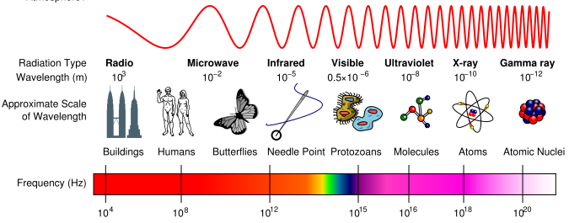
http://en.wikipedia.org/wiki/File:EM_Spectrum_Properties_edit.svg

