Kepler’s Laws of Planetary Motion and Universal Gravitation Law Worksheet
Kepler’s 1st Law: (Circle one) All planetary orbits are (elliptical, circular) in shape.

- A planet is in orbit as shown below. Draw 2 possible locations for a Sun.

- Now sketch and label the following in the drawing above: major axis, semi-major axis, foci, Sun, aphelion, perihelion, planet. Use a ruler or straight-edge as needed.

Kepler’s 2nd Law (AKA ____________________ Law)- a line joining a planet to its sun sweeps out equal areas in equal times as the planets travel along its orbit.

- Use the diagram below to answer the questions.
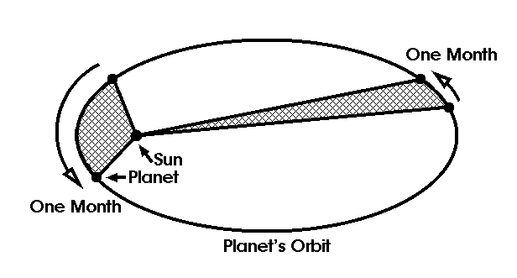
a. Which planet (A or B) is
traveling faster in its orbit?
A
Why?
B

b. Which planet (A or B) is
traveling slower along its orbit?
Why?

c. Circle where the sun is located
in the diagram.

Kepler’s 3rd Law (AKA _________________ Law): The square of a planet’s period equals the cube of the semi-major axis (average distance between the planet and its sun)
.
P² = d³ P = period of revolution (in Earth years) d = (in astronomical units, or AU’s)

- Circle the correct choice in ( ). The period of revolution is equal to a planet’s (day , year).

5. AU stands for ____________________ unit.

6. 1 AU equals 150,000,000 km, which is the average distance between the sun and which planet? ________________________

7. The diagram below shows some of our planets. Use it to answer the questions.
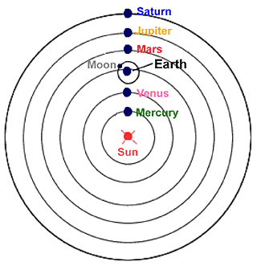
a. Which planet (in the diagram) takes the least
amount of time to travel around the sun?

b. Which planet (in the diagram) takes the longest
amount of time to travel around the sun?

c. Use the equation below to solve for either period of revolution or distance:
P² = d³ P = period of revolution (in Earth years) d = (in astronomical units, or AU’s)

1) A new planet is discovered that is located 16 AUs from its sun. How long will it take to revolve around its sun?(Hint: solve for p)

2) An exoplanet takes 24 years to revolve around the sun. Calculate how far away it is from the sun. (Hint: solve for d)

Newton’s Universal Law of Gravitation: The gravitational force between 2 bodies depends upon their masses and the distance between them.
F = GMm F = force of gravity G = gravity constant 6.67259 x 10⁻¹¹ (N•m²)/kg²
r² M = larger mass m = smaller mass r = radius (distance)

The chart below shows the masses and distance from the sun (compared to earth) for 4 planets. Use the chart to answer the questions that follow.

 | Mercury | Earth | Jupiter | Neptune
Mass | 0.055 | 1 | 318 | 17
Distance | 0.39 | 1 | 5.20 | 30.06

8. Which 2 planets shown above have the strongest gravitational pull? (Hint: look at their

masses) ______________________________________________________

9. Which 2 planets shown above have the weakest gravitational pull? (Hint: look at their

masses) ______________________________________________________

10. Which 2 planets have the most moons? (Hint: their strong gravity attracts more moons).

11. Circle one: If we were to increase the distance between the sun and its planets, the force of gravity between them would (increase, decrease)

Extra challenge: Use the formula above to solve these:

- You are sitting in the family car with your pesky younger sibling. S/He is getting annoyingly close to your “personal space.” Your centers of masses are 0.50 meters apart. If your masses are 50.00 kg and 70.00 kg, then what is the actual scientific force of attraction between the two of you?

- What is the force of attraction between a 60.0 kg student in the senior parking lot and the school? The distance between the two is 100.000 m and the mass of the school 65,000,000 kg.

