Study Questions for Properties of the sun, Measuring the Stars, Galaxies, Cosmology
- Diagram the layers of the sun. Where is the Temperature the highest/lowest? Where is energy generated? What layer do we see? What determines the Sun’s color?

- What is the rough composition of the sun (include %)?

- What is the sun’s energy source? Where does this occur?

- Describe three types of activity found on the sun.

- What are 6 ways that stars can differ from each other? (Think about everything we mentioned)

- What is meant by a light-year? What about a parsec?

- Compare and contrast absolute magnitude and apparent magnitude. Provide an example of when each is useful.

- Which is brighter and apparent magnitude of -2 or +3? How many times brighter is it? What is the dimmest magnitude we can see from Earth without a telescope?

- What is luminosity? What two things does it depend on? How does it relate to absolute magnitude?

- What does parallax measure> Which of the following is the parallax angle? How does the size of the angle compare with the distance of the object?

11. What are the four main types of galaxy shapes? What elements primarily make up the stars found in these galaxies? Roughly what percentage of each element is present?

- Describe Hubble’s law. Be sure you can find the slope pf a line to calculate the Hubble constant.

- What is the distance to a galaxy cluster moving at 1560 km/s? (Assume a Hubble constant of 78 km/s/Mpc). Show all work!

- Describe the Big Bang theory and provide the evidence that support this theory.

- Briefly explain the fate of the universe if it is open, closed, or flat. (Do not worry about how long it takes; they are all a really long ways off.)

15. On the H-R diagram below Fill in the 4 main types of stars as well as their relative temperatures and diameters.

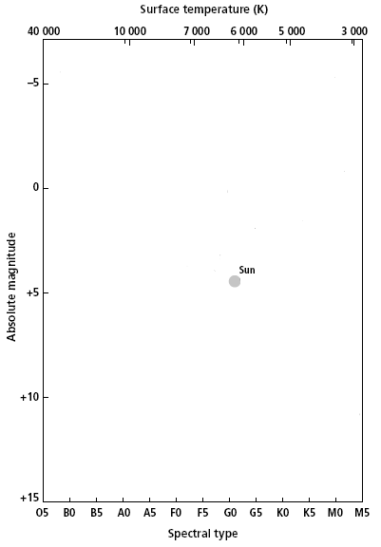

16. Diagram the Milky Way galaxy and label the major parts. What group does it belong to?

