Calculating slope
From http://www.wtamu.edu/academic/anns/mps/math/mathlab/int_algebra/int_alg_tut15_slope.htm

The slope of a line measures the steepness of the line.

Most of you are probably familiar with associating slope with "rise over run".

Rise means how many units you move up or down from point to point. On the graph that would be a change in the y values.

Run means how far left or right you move from point to point. On the graph, that would mean a change of x values.
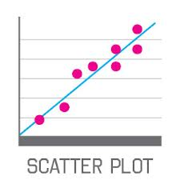
1. Draw your best fit line line:
-For a Scatter plot graph, draw a smooth line that lies as close as possible to most of the points. Do not draw a line that connects one point to the next one as in a dot‐to‐dot drawing. If the curve appears to be straight, draw one continuous line with a ruler.

2. Pick your 2 points. The vertical values are the y points and the horizontal values are the x points.
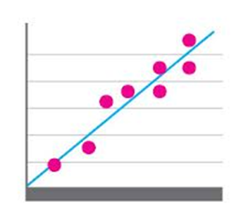
http://visual.ly/learn/scatter-plots-regression-lines

Y₂ = 4

Y₁ = 1

X₂ = 4
X₁ = 1

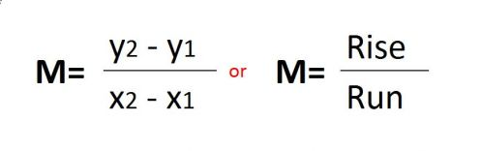

3. Plug the X and Y values into the slope equation and solve.

Using the graph above: 4 - 1 = 1 That’s the slope!
4 – 1 Label the slope on the line above!

