DDN Sept 11, A
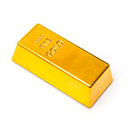
1. Suppose you have a chunk of gold that has a mass of 200g. Its density is 19.32 g/cm³. How much space does the chunk occupy?

2. Now suppose you are feeling generous and you give exactly half of it to your friend. Calculate the density of both pieces of gold. Show the math!

