DDN Sept 23
1. Look around our classroom and give one example of each:
-measurement
-observation
-inference
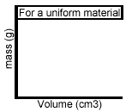
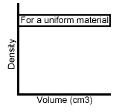
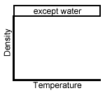
2. Draw a line showing the relationship between the x and y axis

