DDN September 4, A
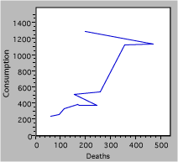

This graph describes deaths due to cigarette consumption. Are there mistakes? If so what are they? Correct them on your paper, and make a simplified corrected graph.

