Name:__________________________________________

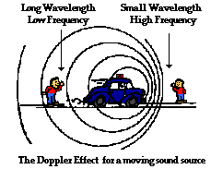
Guided Notes: The Doppler Effect
1. Describe what the Doppler effect is?

2. Describe how the wavelength,
frequency and pitch change when the
police car drives by the observer.

3. Describe how the Doppler effect works in astronomy (blue shifting and red shifting).
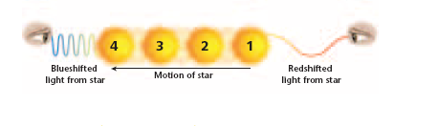

4. Show the direction of the star pictured below. Where is it showing red/blue shift?

5. The diagram below shows the spectral lines for an element.  Which diagram (to the right) best represents the spectral lines of this element when its light is observed coming from a star that is moving towards an observer on Earth? IS this a red or a blue shift? | D

