Electromagnetic Spectrum (Radiation)
Outer space is filled with electromagnetic radiation that travels across space in the form of waves. Only a small portion of the spectrum is visible light- the type most familiar to humans.

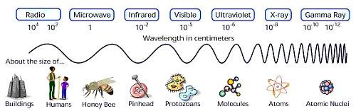
Longest wavelengths, Shortest wavelengths,
Lowest frequencies Highest frequencies

All light travels at the same speed, _____________________________________ m/sec or ______________________________________ km/sec. The speed light is known as the constant c.
Electromagnetic radiation (light waves) differ from sound waves because:

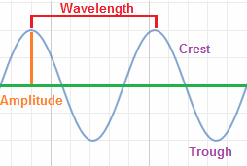
Wavelength is λ, the Greek symbol __________________. It is defined as:

Frequency if f. It is defined as:

Frequency is related to the energy of electromagnetic radiation. For example,
Formulas,tutorvista.com

For all electromagnetic radiation, c = λf This is an _________________________________ mathematical relationship. When wavelength is
long, then frequency is _____________________. Conversely, when wavelength is short, then frequency is _____________________.

We only see a small part of the EM spectrum. What we see is known as the _______________________ region that ranges in ____________________________ in wavelength. The light we see can be divided further into the individual colors that comprise white light. They are:
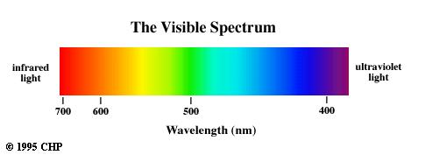
In the visible spectrum, ___________ has the longest
wavelength and least ____________________________,
while _______________ has the shortest wavelength
and most _________________________

