Kepler’s Laws of Planetary Motion and Universal Gravitation Law Worksheet
Kepler’s 1st Law: All planetary orbits are ______________________ in shape.

- A planet is in orbit as shown below. Draw 2 possible locations for a Sun.

- Now sketch and label the following in the drawing above: major axis, semi-major axis, foci, Sun, aphelion, perihelion, planet. Use a ruler or straight-edge as needed.

Kepler’s 2nd Law (AKA ____________________ Law)- a line joining a planet to its sun sweeps out equal areas in equal times as the planets travel along its orbit.

- Use the diagram below to explain how and why a planet’s speed changes as it travels around its sun. Think about when a planet travels faster/slower in its orbit.
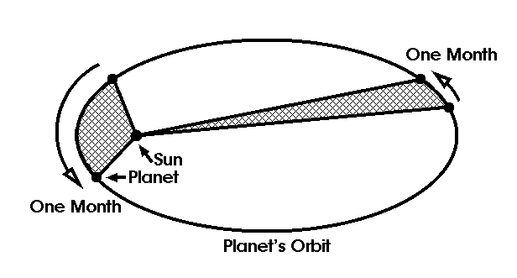

Kepler’s 3rd Law (AKA _________________ Law): The square of a planet’s period equals the cube of the semi-major axis (average distance between the planet and its sun)
.
P² = d³ P = period of revolution (in Earth years) d = (in astronomical units, or AU’s)

- The planet Mercury takes 0.24 sidereal years to go around the sun. What is the distance from the center of Mercury to the center of the sun? (Remember 1 sidereal year = 1 revolution)

- The Planet Jupiter’s mean orbital radius is 5.2025 AU’s. What is the period of Jupiter in Earth years?

- The planet Pluto is 39.5 AU’s from the Sun. How long does it take to go around the Sun once?

- There is belt of asteroids between Mars and Jupiter which circles the “inside” of our solar system. This “Asteroid Belt” has a mean radius from the Sun of 2.6 AU’s. How long does it take for one asteroid in the belt to travel around the Sun once?

Newton’s Universal Law of Gravitation: The gravitational force between 2 bodies depends upon their masses and the distance between them.
F = GMm F = force of gravity G = gravity constant 6.67259 x 10⁻¹¹ (N•m2)/kg2
r² M = larger mass m = smaller mass r = radius (distance)

- You are sitting in the family car with your pesky younger sibling. S/He is getting annoyingly close to your “personal space.” Your centers of masses are 0.50 meters apart. If your masses are 50.00 kg and 70.00 kg, then what is the actual scientific force of attraction between the two of you?

- What is the force of attraction between a 60.0 kg student in the senior parking lot and the school? The distance between the two is 100.000 m and the mass of the school 65,000,000 kg.

- Two asteroids, (m1 = 1.00 X 10¹² kg and m2 = 5 X 10¹² kg), are floating in space. The force of attraction between them is 10.000 N. How far apart are their centers of mass?

- While on the surface of the Earth a student has a weight of 450 N. If she is moved twice as far from the center of the Earth, then how does her new weight compare to her old?
(Hint- use this simplified formula: change in force = 1
distance²

